ПЛАН РОБОТИ
Group name: Historical topics and how they relate to current social and political issues
Members:
- Ann-Sophie Weiß, (Germany)
- Lukas Baur, (Germany)
- Anna Uvarova, (Ukraine)
- Anna-Barbara Schober, (Germany)
- Oleksandr Sapian (Ukraine)
- Nazar Epifanovich (Ukraine)
eTwinning Project Title: History in Context: Understanding Today Through the Past.
Description of Project: This project explores historical events and their connection to today’s social, political, and economic issues. Students from Germany and Ukraine will analyze key moments from their national histories and discover parallels between different countries. Through research, reflection, and digital collaboration, participants will learn how the past shapes the present. (keywords: history, society, politics, reflection, collaboration, education)
Language(s) of the Project: English (main language), with German and Ukrainian used for direct quotations.
Subjects covered: History, Social Studies, Cultural Studies, Education
Competences covered:
- Historical and cultural awareness
- Critical and analytical thinking
- Digital literacy and research competence
- Intercultural communication
- Teamwork and presentation skills
Aims of the Project:
- To enhance students’ understanding of the link between historical events and current global issues by the end of the semester.
- To improve research and critical thinking skills through comparative analysis of national histories.
- To develop digital and communication competences by collaborating with international peers online.
- To produce a shared interactive timeline and visual presentations connecting past and present developments.
Work Process Outline (dates, milestones, who does what)
Week 1 (20-26 Nov): starting to plan the project in more detail, distribute tasks
Week 2 (27 Nov-3 Dec): working on the project/ assigned task
Week 3 (4-10 Dec): working on the project/ assigned task
Week 4 (11-17 Dec): finishing the project/ assigned task
Week 5 (8-14 Jan): final touch, starting with the presentation
Final week (15-21 Jan): finishing presentation
Project Expected Results:
- Interactive global historical timeline
- Multimedia presentations and infographics
- Short research reports and essays
Image for the eTwinning Twin Space

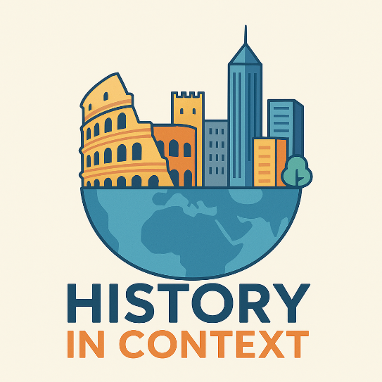

Will you use an eTwinning Toolkit?
We will use various websites about our topic and Canva, but if the opportunity arises to use eTwinning Toolkit, we will definitely turn to it!

ЗАВДАННЯ, ЯКІ МИ РОЗРОБЛЯЛИ

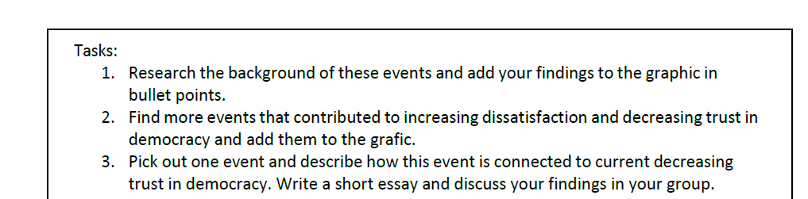

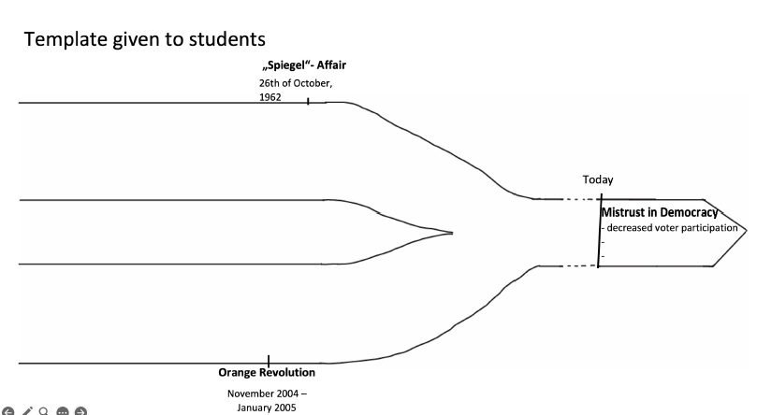
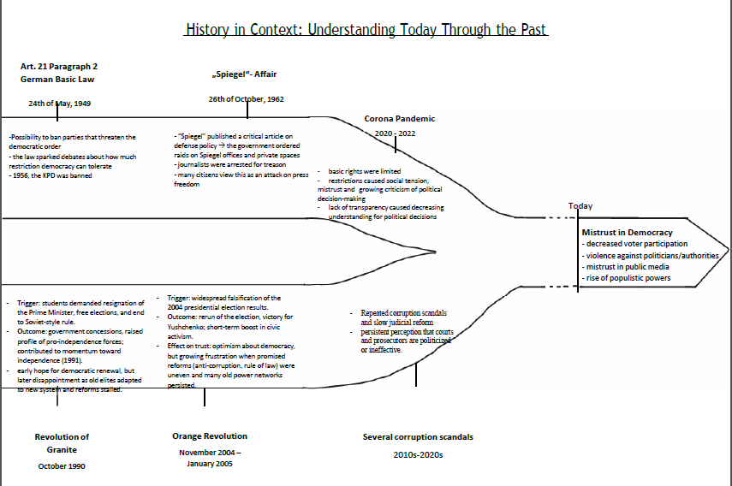

ПОСИЛАННЯ НА ВІЗУАЛІЗАЦІЮ ЗАВДАНЬ:
https://www.canva.com/design/DAHA2k_D508/19qwStAS2lAvhBAikwq-tQ/edit?utm_content=DAHA2k_D508&utm_campaign=designshare&utm_medium=link2&utm_source=sharebutton

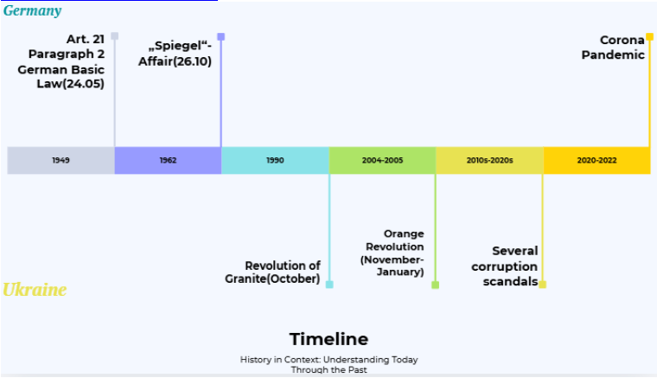

ПОСИЛАННЯ НА ЛІНІЮ ЧАСУ Й ПРЕЗЕНТАЦІЮ:
https://www.canva.com/design/DAHA8Zph0GQ/34nfpGjqPuwSdc0YwFWxRw/edit?utm_content=DAHA8Zph0GQ&utm_campaign=designshare&utm_medium=link2&utm_source=sharebutton
ПОСИЛАННЯ НА СТОРІНКУ ПРОЄКТУ НА ETWINNING ТА TWINSPACE:
https://school-education.ec.europa.eu/en/etwinning/projects/history-context-understanding-today-through-past

Lessons Learned/After Action Report Organizer

Group/Project Name: History in context: understanding today through the past (Group 12)

Group Members: Nazar Epifan, Anna Uvarova, Anna-Barbara Schober, Lukas Baur, Ann-Sophie Weiß

Area | What Went Well | What Could Have Been Better | What We Learned
Group Work & Collaboration | - communication via Whatsapp  - always informed others about the group project or about absence | - nothing really | - how important communication and dialog is  - how important various perspectives are
Group Meetings | - additional zoom meetings  - clear and respectful communication  - supportive atmosphere | - more attendance in the additional zoom meeting | - despite starting problems, we found the right time to meet up and to discuss our project
Division of Work | - equally distributed workload  - every participated in the presentation and the project | - motivated the quitting member to participate | - how important it is to divide projects in task packages
Time Management | - setting up deadlines  - meeting those deadlines  - dividing the project in equally complex tasks | - setting up our goals earlier  - | - efficient time management  - taking breaks and not to stress
Finding Partners | - finding partners very quickly  - quickly creating a Whatsapp group and inviting team members to it | - we lost one team member | - it’s helpful if everyone is polite and respectful  - shared interests help forming a group/making it effective
Using eTwinning Portal | - we are all validated  - created a project | - using the twinspace more often  - using eTwinning to search for interesting projects/webinars | - eTwinning is a powerful tool but not as easy to use  - there are huge opportunities how to use eTwinning
Other (as needed)

Introduction
This project explores historical events and their connection to today’s social, political, and economic issues. Students from Germany and Ukraine will analyze key moments from their national histories and discover parallels between different countries. Through research, reflection, and digital collaboration, participants will learn how the past shapes the present. The purpose of this report is to provide an overview of what went well and what could have been better to focus on what we learned about doing an eTwinning project with the eTwinning portal and international partners.

What Went Well

1. communication via Whatsapp
2. equally distributed workload
3. setting up deadlines and meeting them
4. respectful behaviour within the group

What Could Have Been Better

1. using eTwinning/the twin space
2. more attendance in the additional zoom meeting
3. setting up our goals earlier

What We Learned

1. how important communication and dialog is
2. how important it is to divide projects in task packages
3. the richness of intercultural exchange and collaboration
4. efficient time management

